**PROGRAM – 1**

**Write a program to implement linear search**

#include<stdio.h>

void main()

{ int n,i,k,f=0,a[100];

printf("enter the size of array: ");

scanf("%d",&n);

printf("enter elements in array: ");

for(i=0;i<n;i++)

scanf("%d",&a[i]);

printf("enter the element to be searched: ");

scanf("%d",&k);

for(i=0;i<n;i++)

if(a[i]==k)

{ printf("the element was found at %d",i);

f=1;

break;

}

if(f==0)

printf("the element was not found");

}

**OUTPUT**

**CASE 1:** Elementfound

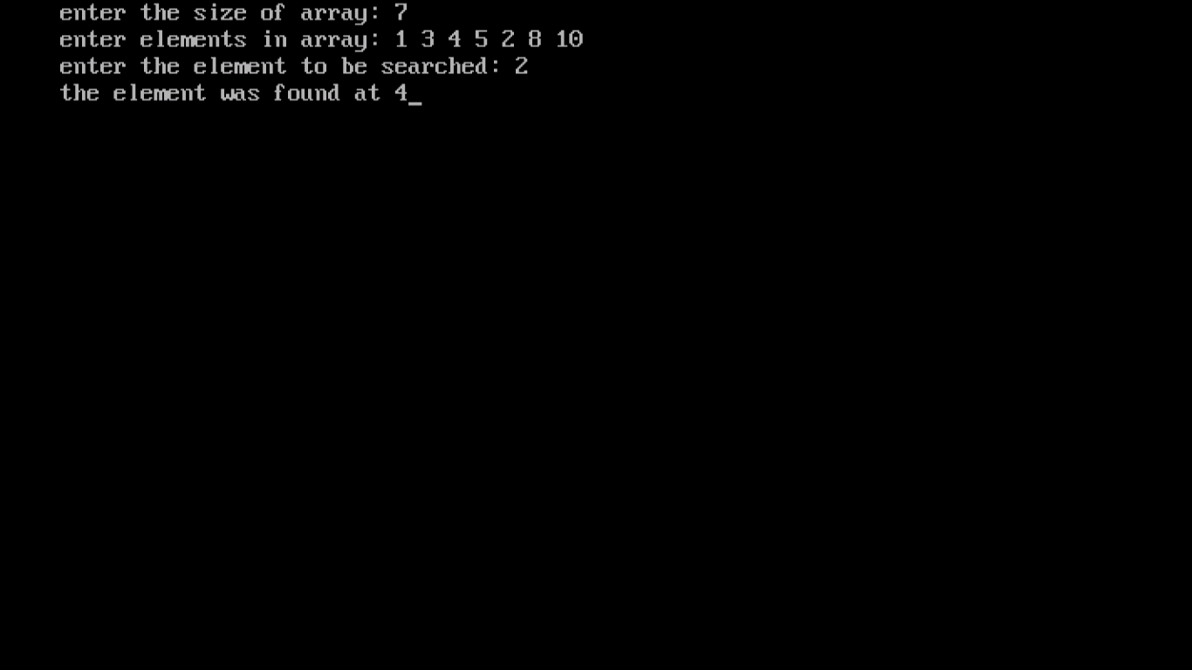

**CASE 2:** Element not found

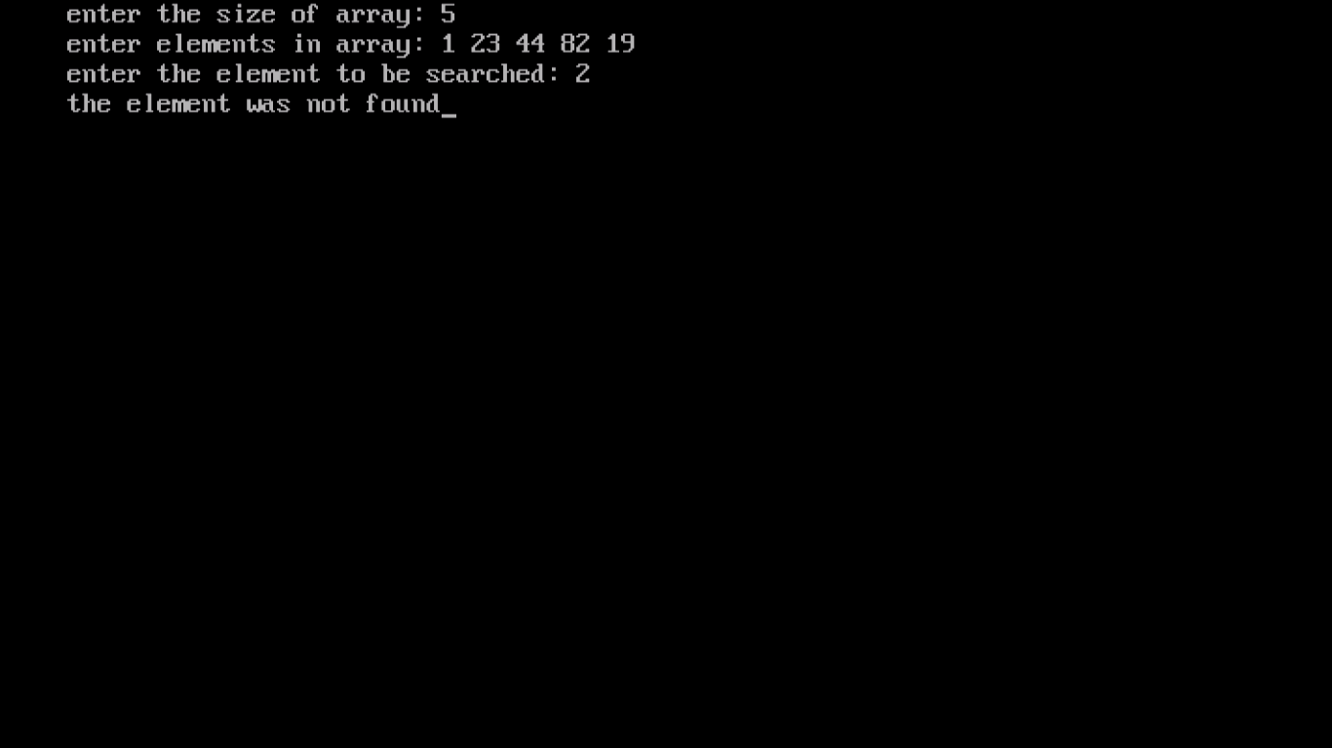

**PROGRAM – 2**

**Write a program to implement binary search**

#include <stdio.h>

#include<conio.h>

int main()

{

clrscr();

int i, l, h, mid, n, key, array[100];

printf("Enter number of elements: ");

scanf("%d",&n);

printf("Enter sorted elements in ascending order:\n");

for(i = 0; i < n; i++)

scanf("%d",&array[i]);

printf("Enter the number to search: ");

scanf("%d", &key);

l = 0;

h = n - 1;

mid = (l+h)/2;

i=0;

while (l <= h)

{

if(array[mid]==key)

{

printf("The element was found at %d",mid+1);

i=1;

break;

}

else if(array[mid] < key)

l = mid + 1;

else

h = mid - 1;

mid = (l + h)/2;

}

if(i==0)

printf("The element was not found");

getch();

return 0;

}

**OUTPUT**

**CASE 1:** Element found

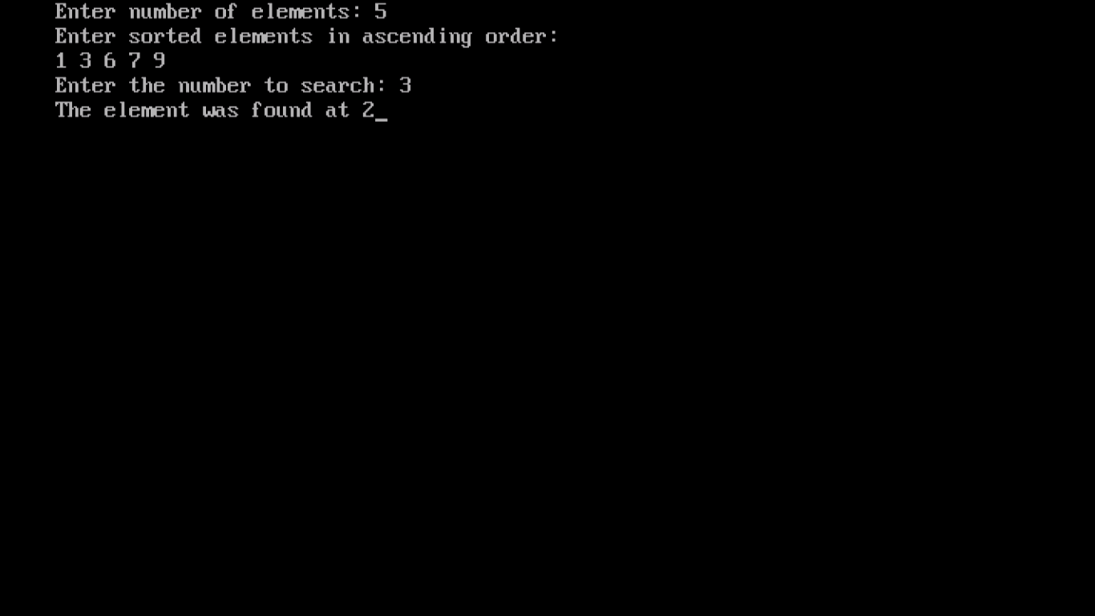

**CASE 2:** Element not found

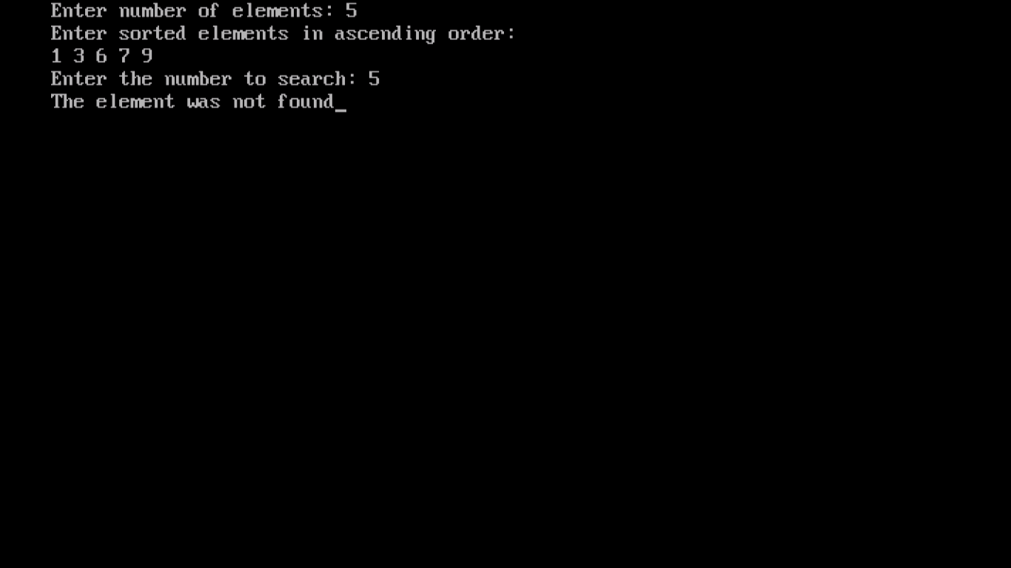

**PROGRAM – 3**

**Write a program to implement bubble sort**

#include <stdio.h>

void main()

{ int i, j, temp, n, arr[100];

printf("Enter number of elements: ");

scanf("%d",&n);

printf("Enter elements in array:\n");

for(i = 0; i < n; i++)

scanf("%d",&arr[i]);

for (i = 0; i < n-1; i++)

for (j = 0; j < n-i-1; j++)

if (arr[j] > arr[j+1]){

temp = arr[j];

arr[j] = arr[j+1];

arr[j+1] = temp;

}

printf("Sorted array:\n");

for (i=0; i < n; i++)

printf("%d ", arr[i]);

}

**OUTPUT**

